**ITS290F Human Computer Interaction & User Experience Design**

**Lab 5. Bootstrap (part 2)**

What you’ll learn in this lab:

* Bootstrap 4

**1. Readings**

Suggested readings from w3schools

1. Bootstrap 4 tutorial

<https://www.w3schools.com/bootstrap4/>

1. Bootstrap 4 Grid System

<https://www.w3schools.com/bootstrap4/bootstrap_grid_system.asp>

1. Responsive Web Design

<https://www.w3schools.com/css/css_rwd_intro.asp>

**2. Lab Exercises**

On your own, follow the instructions to finish the UI coding exercises. You may edit the code with any text editor. Put your solution code to the solution textboxes in the worksheet when finished.

**Exercise 1**

Download file **T05Ex01.html** and open it with a text editor (preferably Notepad++ if you use Windows). Study the code and answer the following questions.

|  |
| --- |
| 1. How many rows inside the grid? |
| 3 |

|  |
| --- |
| 1. How many columns in the first row? |
| 4 |

Open the file **T05Ex01.html** with a recent web browser. The webpage is an image viewer that shows four image thumbnails and a preview image. When the user clicks on the thumbnail, the corresponding preview image will then show up on the image pane. The layout of the page is as follows:

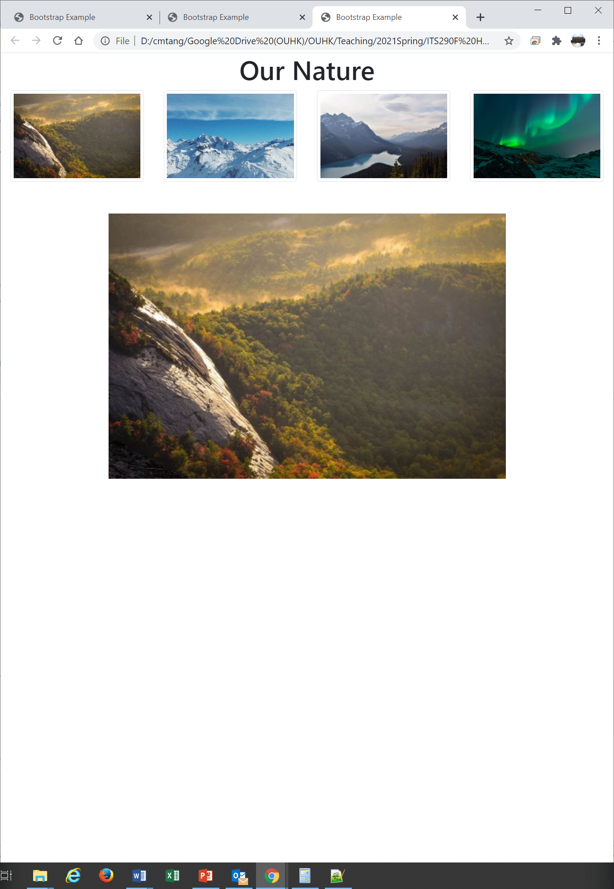

Now we want to reorganize the layout of the page. The new page should display the image thumbnails vertically on the left while display the preview image on the right. The width of the thumbnails should occupy ¼ of the screen while the width of the preview image should occupy ¾. You should create two columns for the thumbnails and the preview image with bootstrap’s grid system. The new layout of the page should look like the follows:

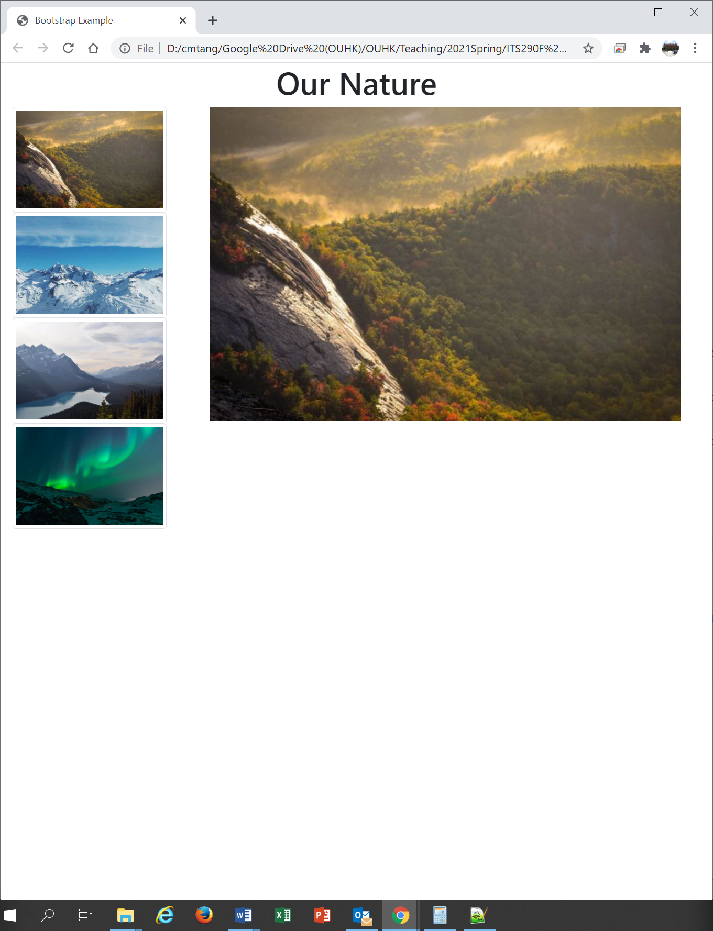

Make a copy of the file **T05Ex01.html** and name it as **T05Ex02.html**. Modify the latter to create the above new layout.

**Hints:** The 2nd and 3rd rows of the original page display the thumbnails and the preview image, respectively. You may create two columns to substitute the rows. Note that the columns must rely on a row and you should use column span to set the desired width. This time you do not need to consider the screen sizes of target devices.

|  |
| --- |
| 1. Which column class should be adopted for the thumbnails? |
| Col-md-3 |

|  |
| --- |
| 1. Which column class should be adopted for the preview image? |
| Col-md-9 |

|  |
| --- |
| 1. Submit the <body> section of your solution **T05Ex02.html** file here. |
| <body>  <div class="container-fluid">  <div class="row justify-content-center">  <h1>Our Nature</h1>  </div>  <div class=" row">  <div class="col-md-3" onclick="preview(event)">  <div>  <img class="img-fluid img-thumbnail" src="https://www.w3schools.com/howto/img_nature.jpg">  </div>  <div >  <img class="img-fluid img-thumbnail" src="https://www.w3schools.com/howto/img_snow.jpg">  </div>  <div>  <img class="img-fluid img-thumbnail" src="https://www.w3schools.com/howto/img_mountains.jpg">  </div>  <div>  <img class="img-fluid img-thumbnail" src="https://www.w3schools.com/howto/img_lights.jpg">  </div>  </div>  <div class="col-md-9">  <img id="preview" class="img-fluid">  </div>  </div>  </div>  </body> |

**Exercise 2**

The new webpage you created in **Exercise 1** is suitable to display on larger screens with landscape orientation. However, it would be problematic when displaying on smaller screens or in portrait orientation. Therefore, you want to modify the page to make it responsive to the screen sizes. Specifically, you want to display the contents of the page normally on medium or larger screens (breakpoint md or up), but show only the thumbnails (hide the preview image) on smaller screens (below breakpoint md).

Make a copy of the file **T05Ex02.html** and name it as **T05Ex03.html**. Modify the latter to create the responsive web page.

**Step 1.** Update and add necessary classes to the second column, which control the visibility of the preview image on different screen sizes. **Hints:** See pages 36-37 of the lecture slides.

|  |
| --- |
| 1. What class(es) should be included in the second column? |
| <div class="__d-md-none d-lg-block___" style="text-align:center;">  <img id="preview" class="img-fluid">  </div> |

If your coding is correct, you may then probably see that the preview image in the second column is disappeared when displaying on a “smaller” device. However, the thumbnail portion does not expand to the full width of the screen like the follows, which looks a bit ugly:

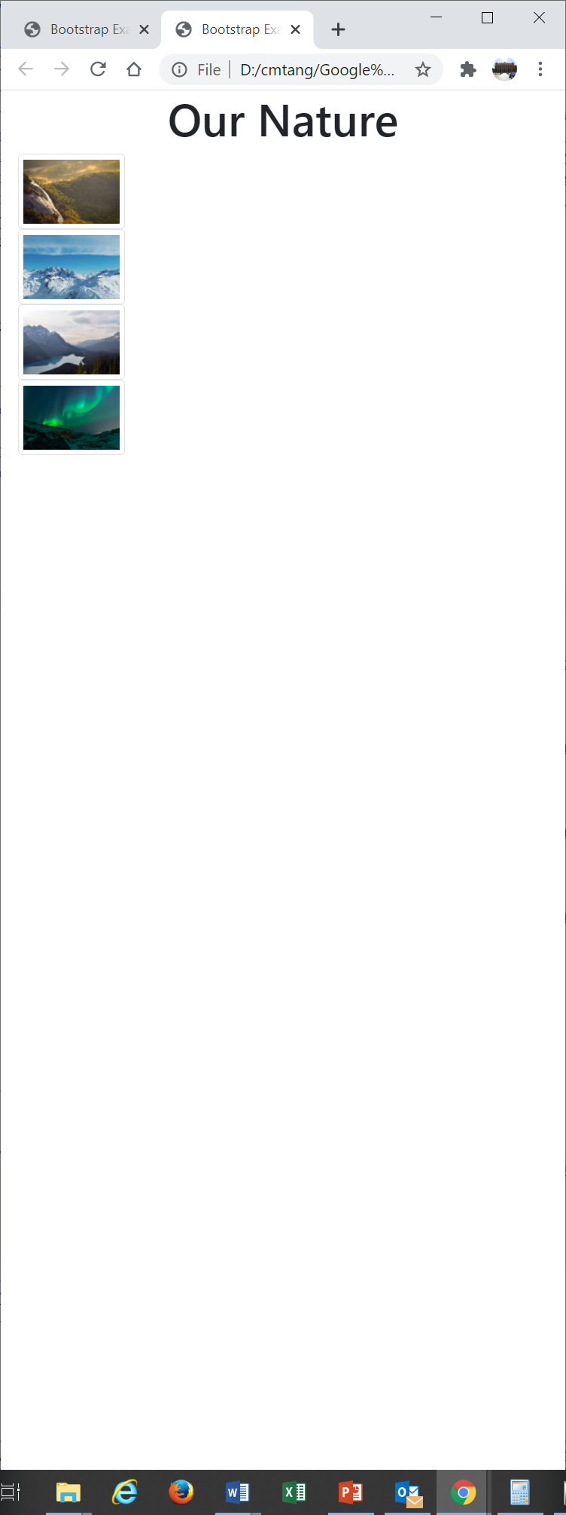

There is a need to expand the width of the thumbnail column to 100%, which looks like the follows:

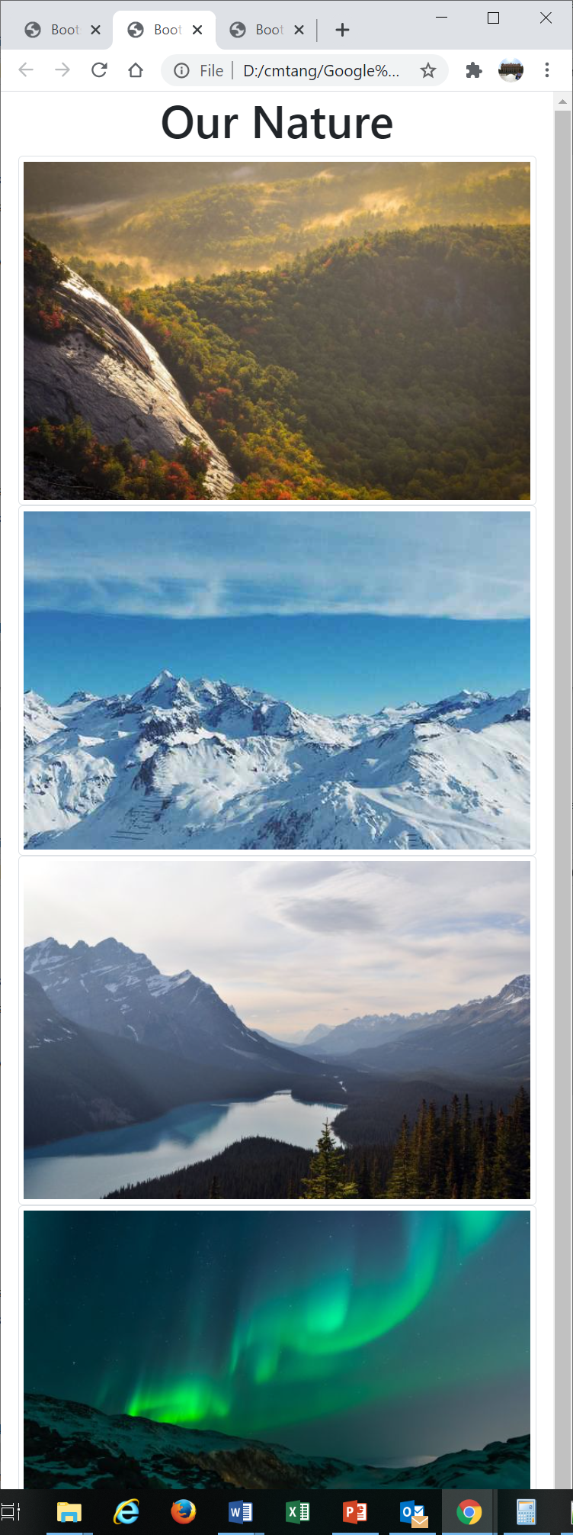

**Step 2.** Add necessary classes to the first column to expand its width to 100% when the preview image is hidden (below breakpoint md). **Hints:** See page 27 of the lecture slides.

|  |
| --- |
| 1. What class(es) should be included in the first column so that it could be resized automatically on smaller screens? |
| <div class="___col-md-12 col-lg-3_______"> |

|  |
| --- |
| 1. Submit the <body> section of your solution **T04Ex03.html** file here. |
| <body>  <div class="container-fluid">  <div class="row justify-content-center">  <h1>Our Nature</h1>  </div>  <div class=" row">  <div class="col-md-12 col-lg-3" onclick="preview(event)">  <div>  <img class="img-fluid img-thumbnail" src="https://www.w3schools.com/howto/img_nature.jpg">  </div>  <div >  <img class="img-fluid img-thumbnail" src="https://www.w3schools.com/howto/img_snow.jpg">  </div>  <div>  <img class="img-fluid img-thumbnail" src="https://www.w3schools.com/howto/img_mountains.jpg">  </div>  <div>  <img class="img-fluid img-thumbnail" src="https://www.w3schools.com/howto/img_lights.jpg">  </div>  </div>  <div class="col-lg-9 d-md-none d-lg-block">  <img id="preview" class="img-fluid">  </div>  </div>  </div>  <script>  document.getElementById("preview").src="https://www.w3schools.com/howto/img_nature.jpg";  function preview(event) {  document.getElementById("preview").src = event.target.src;  }  </script>  </body> |

**Submission**

You will get 0 to 3% of OCAS score upon completing the lab exercises.

1. Put your solution code inside the answer boxes and save the file.
2. Upload this file via the corresponding submission link on OLE.

**Note:**

1. The submission deadline is 23:59 of the forthcoming Thursday. The submission link will be closed after the deadline.
2. We mainly focus on the correctness and quality when grading your work.
3. Make sure you submitted a correct file. You can resubmit your work before the deadline.

1. DO NOT modify the layout and format of this document, and DO NOT save it as other file formats, i.e., PDF. Your work will be extracted using an automated document parsing tools for grading.

--- End ---